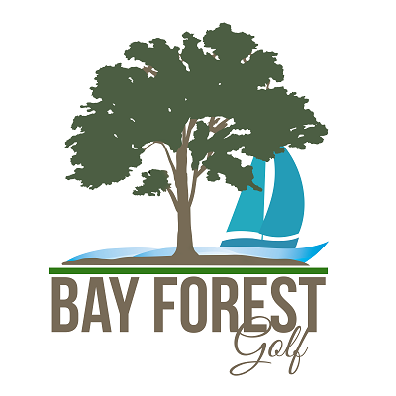
Monday, October 17th, 2022
1:00PM Shotgun Start
Bay Forest Golf Course
Welcome Bulldog alumni and guests! In 1989, a few individuals formed the Bay Forest Junior Golf Association to support junior golf, resulting in the annual Bay Forest Junior Championship tournament and many scholarships within the community. This year, Bay Forest will be hosting the La Porte Bulldog Alumni Golf Tournament to further the impact of one of our most anticipated traditions.

In the beginning, the Bay Forest Junior Golf Association and Bay Forest staff would sign-up local and regional junior golfers for its annual junior tournament. As more junior golf associations and tournaments developed across Texas, it has become increasingly more competitive to register players. Bay Forest now partners with the Southern Texas PGA and Srixon Junior Tour to further elevate the Bay Forest Junior Championship tournament among other junior tournaments.

Unlike some of the other junior tournaments, the Bay Forest Junior Championship prides itself on the hospitality provided to the junior golfers. Meals are served to players after each round; members of the community staff tents with drink stations and snacks across the golf course; and junior golfers also submit a scholarship application to the Bay Forest Junior Golf Committee. Since 1995, scholarships have been awarded when available. All these efforts are the result of the Bay Forest Junior Golf Association and its community of volunteers.

In celebration and support of the Bay Forest Junior Champion, all proceeds from the La Port Bulldog Alumni Golf Tournament will benefit the Bay Forest Junior Golf Association and its legacy of supporting junior golf for more than 30 years.

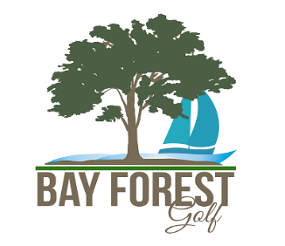

Date: Monday, October 30th, 2023
Check in: 10:30am to 12:00pm
Format: Four person scramble
Entry Fee: $500.00 per team; first paid 30 teams
(Fee includes; green fee, cart, range, (2) mulligan per player, lunch and dinner)
Prizes: 1st, 2nd, 3rd place; Closest to pin & Long Drive

Hole Sponsor Sign: $125 per sign

Name on Hole Sponsor Sign:___________________________________

Entry Form
Top Bulldog Name:____________________________________
Team Name:________________________________________________
Email Address:________________________________________________
Phone Number:________________________________________________
Player 2 Name:________________________________________________
Player 3 Name:________________________________________________
Player 4 Name:________________________________________________

To assure yourself a spot in the tournament, please complete the form and mail entry form to: Bay Forest Golf Course; 201 Bay Forest Dr., La Porte, Texas 77571

Make checks payable to: Bay Forest Junior Golf Association
201 Bay Forest Dr, La Porte, TX. 77571

